**Research Topics List**

**Computer Vision -** analyze and interpret visual information from images and videos

1 Image Processing

2 object detection

3 image classification

4 object tracking

5 3D vision

6 Facial recognition

7 Gesture recognition

8 Scene Understanding

9 Medical Imaging

10 Autonomous Vehicles

**Artificial Intelligence -** systems that perform tasks requiring human intelligence

**1** **Weak/Narrow AI -** well designed for specific task and it’s application but no general intelligence

1 NLP

2 Computer vision

3 Recommendation Systems

4 Medical Diagnosis

5 Finance

6 Gaming

**2 Strong/General AI -** complete human like intelligence but still a theoretical concept to a large extent

**Machine Learning -** subdomain of AI that focuses on building systems that learn and predict from the data , give computers the ability to improve their performance through experience.

1. Supervised learning
2. Unsupervised Learning
3. Reinforcement Learning

Including what they are , how it works and where they are used.

**Artificial Intelligence + Computer Vision**

* **Natural language processing(NLP)**
* At present, it is the most used field of AI which is basically the interaction with computers in human language
* It's a must to explore today coz. The CHATGPT we use today is highly based on the concepts of NLP and its components.
* Key components are,

1. Text Analysis - It starts by analyzing the data by tokenization i.e. breaking whole text to words or small phrases and then stemming which is reducing that words to the root form considering grammatical role.
2. Named Entity Recognition - It basically identifies nouns like names , places,dates and more which basically helps for information extracting and question answering.
3. Sentiment Analysis - determines the emotional tone of a piece of text, and used to identify opinion or feedback from users.

* There are other essential components like machine translation,text summarization,question answering and many more.
* APPLICATION: chatbots, feedback systems on text and many more domains.

* **Computer Vision**
* A vast field of AI that focuses on making computers understand visual information(from digital images and videos) and performing actions based on what they see, much like the human visual system.
* Key Aspects of Computer vision include,

1. Image Processing - IP algorithms basically sense and extract some features and information from digital Image . In this, techniques like edge detection and image segmentation i.e it partitions the image into multiple parts based on pixels in image and then interpret information from them.

This kind of Image segmentation thing is highly used in deep learning techniques which

identifies the text written in any manner dividing it into 28*28 parts and assigning some

weights to them.

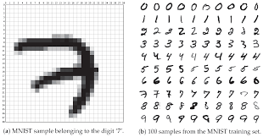

Fig 1. Deep learning technique i.e. neural networks of 2 layers specifically(here) used

to identify 7 by image segmentation i.e. by breaking this into 28*28 pixels image and

assigning some weights to them and some deep mathematics behind it.

*Source* - [But what is a neural network? | Chapter 1, Deep learning](https://www.youtube.com/watch?v=aircAruvnKk)(for deep

learning).

1. Object Detection/Tracking - Here Object Detection algorithms are trained to locate some specific objects within images and videos by recognizing them even in complex scenes.

This is must used concept everywhere like in autonomous driving, robot vision,

Healthcare monitoring likes to detect specific diseases in X-Rays,MRI’s and much more.

So, I must explore this.

Object Tracking involves monitoring the movement of objects over time in videos by

tracking the path they follow.

1. Image Classification - This includes Classification Algorithms which just categorize images into our custom defined categories . Can classify any type of images .

This is example of *Supervised Learning Problem* that train a model to recognize and

classify objects/images using already trained large datasets of photos.It works by

assigning labels to a group of images based on some criteria.

CNN(Convolutional Neural Network) : A artificial neural network that learns directly from

data . They are mostly used for finding patterns and similarities in images to recognize

objects, classes and categorize them on some criteria .

Watched video for cnn : <https://www.youtube.com/watch?v=QzY57FaENXg>

1. Facial Recognition - These algorithms use computer vision to identify and verify individuals by their facial features. Heavily used in security applications, authentication and personalization. Used to identify people in images, videos in real time.

There are many face recognition techniques like

a. Holistic Matching

b. based on Feature

c. based on model

d. Hybrid methods

The most commonly used method is Hybrid.

*Hybrid Method* - In this 3D images are used . So, after image is captured , curves of

eyes or shapes of the chin or forehead are matched.Any face can be taken as input but

giving enough features to make a full face. It includes detection,position measurement, Representation and Matching.

I particularly liked this domain bcoz it is used vastly nowadays as most oftenly we see it iphone locks,that’s why i quite explored this.

*Source* - <https://iq.opengenus.org/techniques-for-face-recognition/>

1. Autonomous Vehicles - Nowadays, all self-driving cars rely mostly on computer vision techniques to get all timely updates of surroundings , enabling them to make real-time decisions for safe navigation.

They work mostly on 4 main principles:

1. Environmental Perception
2. Behavioral Decision-making
3. Path-planning
4. Motion control

* There are many more areas where computer vision is widely used like,

1. Gesture recognition
2. Scene Understanding
3. Medical Imaging

and many more……

* The last topics I mentioned , have been briefly explored by me, that is what they are where used!!
* Weak AI is used in vast areas like for recommendation systems(content based platforms use), Medical Diagnosis(diagnosing diseases from medical images) and analyzing patient data to predict risk. Also used in Finance for algorithmic trading like in HFT’s and customer service chatbots.Also used in Gaming.

**Most common tools used for learning and building in AI+ML,**

1. Scikit learn - widely used AI tool to simplify the complexities of ML tasks and provides exclusive functions for building in areas like data processing, evaluation and evaluation. To deploy machine learning models easily.
2. Tensor flow - most desired machine learning framework using python open source library that facilitates numerical computation making future predictions much easier.
3. Pytorch - Python AI tool , similar to tensorflow but is being selected for faster development.Used when projects involve larger and more complex projects.
4. Keras - Renowned for building and training neural networks. Having good interface and pre-built layers, used to create powerful models like Image Recognition and Natural Language Processing. Makes understanding of deep-learning with ease.

1. Jupyter Notebook(AI develop. environment) - Interactive web-based tool that allows us to write and execute code in a document style environment. Good to visualize our algorithms along with results.

Navigating through youtube videos , I found this documentation which is at best for learning all tools available and to be at the same pace as AI is a growing field.

Link - <https://www.futurepedia.io/> (Documentation and Resources)

**Machine Learning**

* Subfield of AI that builds algorithms and models which learn from data and makes predictions based on what they learnt without being explicitly programmed.
* Machine Learning techniques;

1. *Supervised learning* - Here the machine is already trained by labeled datasets i.e. with specific input-output pairs , these datasets are designed to supervise algorithms predicting outcomes accurately.

Major Types of problem in this is as follows,

a. *Classification* - This problem uses algorithms to accurately

assign test data into categories on which it is already trained.

Linear classifiers, support vector machines and decision trees are all common types of classification algorithms.

b. *Regression* - highly useful to predict numerical values based on what the machine has learnt from previous relationships between dependent and independent variables.

1. *Unsupervised learning* - In this, the machine is provided with dataset but not like inputs just as a cluster of all , and then machine learning algorithms discover the hidden patterns in data without human intervention,hence unsupervised.

Majorly used for,

a. *Clustering -* in most simple words, it is grouping of objects in

such a way that objects in same group are more similar to each other than those in other groups i.e on basis of similarity and dissimilarity

Used to identify groups of similar objects in datasets with many variable quantities and it forms groups of specific rows showing similarities in those quantities.

Ex: K-means clustering assigns similar data points into groups where k represents the size of the group and is largely used for market segmentation , image compression(lossy and lossless techniques).

b. *Association -* This unsupervised learning method uses different

rules to find similarities between given variables in a dataset and

then predict what can be the value of particular based on other

variables.

It is frequently used for market analysis and recommendation

engines where it can suggest items based on previous orders by

customers.

c. *Dimensionality Reduction* - In this process, number of features in

a dataset is reduced while retaining as much as information

possible . This can be done to reduce the complexity of a model to

improve the performance of a learning algorithm.

1. *Reinforcement learning* - It is used to find the best possible behavior or path that machine should follow in specific situations. It is done by taking

Suitable action to maximize the REWARD in a particular situation. In this , the machine doesn’t know the correct answer unlike in supervised learning, so it follows some paths and from experience gives the best path as outcome having highest reward.

It’s like decision making.

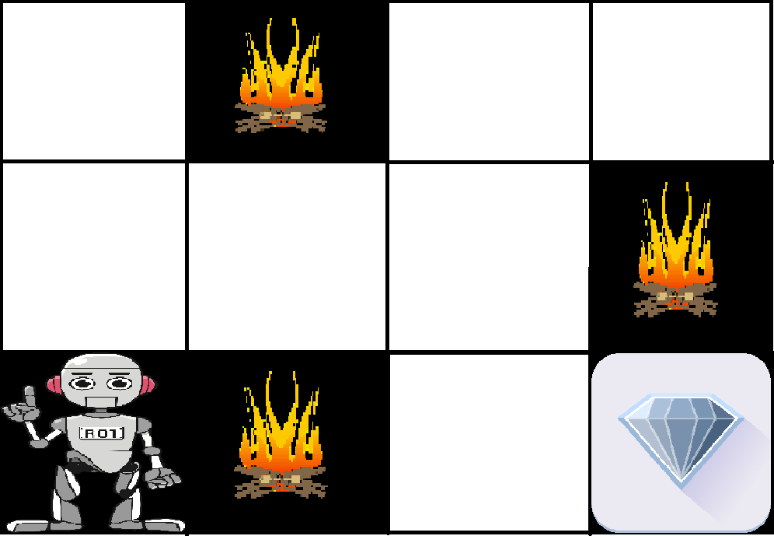.

Fig 2. In the above image, the robot has to find a way to diamond. Every right step will give the robot a reward and each wrong step will subtract the reward of the robot.The best path would be having the maximum reward.(Source - GeeksForGeeks)

Elements of Reinforcement Learning,

1. Policy - the learning agent behavior for a given time period. It decides what action to be taken in particular states.
2. Reward function - used to define a goal in R.L. problem and it provides a numerical score based on that state of environment .
3. Value Function - The value of a state is the total amount of reward an agent can expect over the future starting from that state.
4. Model of the Environment - models are used for planning of the path.

Applications: Robotics, puzzles, chess and many ,image processing and

many more.

How Image Processing? This was a question that came to my mind.So, I

found that when an image is processed , it will start by searching an entire

image as starting point and identify objects sequentially until they get

Everything.

Best Python Libraries for machine learning - Numpy,Scipy,PyTorch, Pandas,TensorFlow.

**What I got to know by researching all this?**

To be honest , I have previously watched the Harvard CS50 course of Artificial Intelligence in Python([Harvard CS50’s Artificial Intelligence with Python – Full University Course](https://www.youtube.com/watch?v=5NgNicANyqM&t=7893s))

Though I don’t know that great level of python but still know much decent level , I was trying to know algorithms that are made fast with various techniques and how they are approached.

This developed my interest in AI algorithms that how they work in real life like google maps, games and much more…

After doing this Research work , I found that using AI as a keyword is very vague bcoz. AI is a very vast field as it itself says Intelligence and that includes every model that can function and perform action like the human brain.

So , as of now I decided to go with the fundamental topics that build Intelligence that are Machine Learning and Deep learning techniques.Then anytime in future , I can get to know more about AI principles and more complex algorithms.

AS OF NOW,

INCLINED TOPICS → MACHINE LEARNING AND DEEP LEARNING.

Sources Used:

1. Chatgpt
2. GeeksForGeeks
3. Youtube videos(already mentioned before)
4. IBM blogs
5. First google search answers

—----------------------------------------- Thank You —---------------------------------------------